SE Assignment 1
Muhammad Qasim
Teacher: Sir Javed Abbasi
Scrum Implementation Using GitHub Repository and Kanban Project

1.
https://github.com/Kas-sim/lab-agile-planning

2.
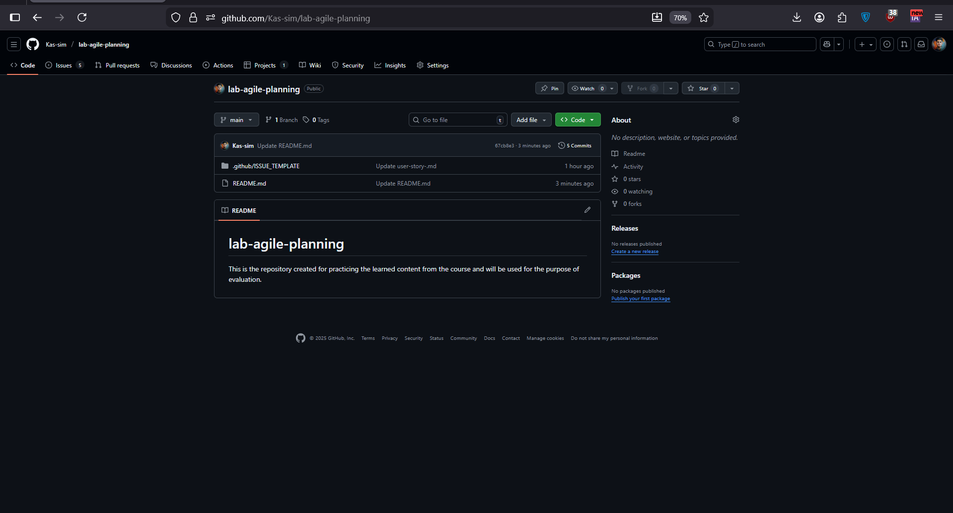

3.
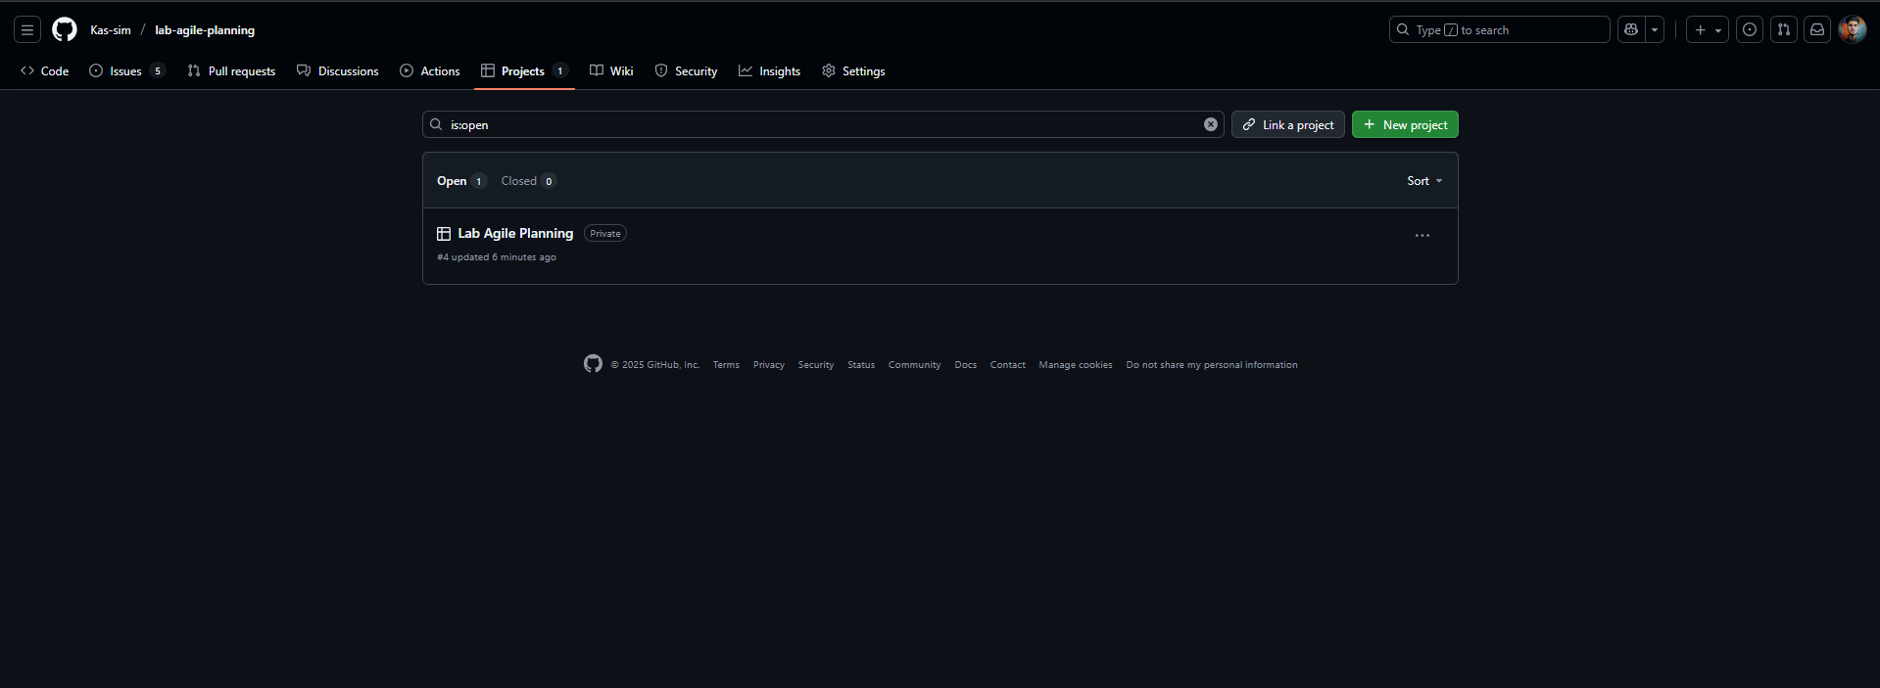

4. 